温州大学瓯江学院

**WENZHOU UNIVERSITY OUJIANG COLLEGE**



《网页设计》

实 验 报 告

|  |  |  |  |
| --- | --- | --- | --- |
| 专　 业 | 电子商务 | 班　级 | 二班 |
| 学生姓名 | 余淑玲 | 学　号 | 18219111132 |
| 指导教师 | 邱儒 | | |

温州大学瓯江学院教务部制

**网页设计**

1. **实验目的**

**使用html、bootstrap、css等创建一个个人网页**

1. **实验环境**

**Bootstrap、GitHub、联网电脑**

1. **网页代码**
2. **shouye**

**<!DOCTYPE html>**

**<html lang="zh-cmn-Hans">**

**<head>**

**<meta charset="utf-8">**

**<meta name="viewport" content="width=device-width, initial-scale=1, shrink-to-fit=no">**

**<meta name="description" content="">**

**<meta name="author" content="">**

**<title>四季</title>**

**<!-- Bootstrap core CSS -->**

**<link href="vendor/bootstrap/css/bootstrap.min.css" rel="stylesheet">**

**<!-- Custom fonts for this template -->**

**<link href="vendor/fontawesome-free/css/all.min.css" rel="stylesheet" type="text/css">**

**<link href='https://fonts.googleapis.com/css?family=Lora:400,700,400italic,700italic' rel='stylesheet' type='text/css'>**

**<link href='https://fonts.googleapis.com/css?family=Open+Sans:300italic,400italic,600italic,700italic,800italic,400,300,600,700,800' rel='stylesheet' type='text/css'>**

**<!-- Custom styles for this template -->**

**<link href="css/clean-blog.css" rel="stylesheet">**

**</head>**

**<body>**

**<!-- Navigation -->**

**<nav class="navbar navbar-expand-lg navbar-light fixed-top" id="mainNav">**

**<div class="container">**

**<button class="navbar-toggler navbar-toggler-right" type="button" data-toggle="collapse" data-target="#navbarResponsive" aria-controls="navbarResponsive" aria-expanded="false" aria-label="Toggle navigation">**

**目录**

**<i class="fas fa-bars"></i>**

**</button>**

**<div class="collapse navbar-collapse" id="navbarResponsive">**

**<ul class="navbar-nav ml-auto">**

**<li class="nav-item">**

**<a class="nav-link" href="shouye.html">主页</a>**

**</li>**

**<li class="nav-item">**

**<a class="nav-link" href="chun.html">四季</a>**

**</li>**

**</ul>**

**</div>**

**</div>**

**</nav>**

**<!-- Page Header -->**

**<header class="masthead" style="background-image: url('img/1.jpg')">**

**<div class="overlay"></div>**

**<div class="container">**

**<div class="row">**

**<div class="col-lg-8 col-md-10 mx-auto">**

**<div class="site-heading">**

**<h1 style="font-family:楷体;font-size:100px;">四季的魅力</h1>**

**<span class="subheading" style="font-family:楷体;" >人生的旅途，一路都是风景</span>**

**</div>**

**</div>**

**</div>**

**</div>**

**</header>**

**<!-- Main Content -->**

**<body style="text-align:center;">**

**<div class="jumbotron">**

**<h1 style="font-family:宋体;">游在旅途，四季如画!</h1>**

**<div class="row">**

**<div class="col-xs-6 col-md-3">**

**<a href="#" class="thumbnail">**

**<img src="img/shouye1.jpg" alt="...">**

**</a>**

**</div>**

**<div class="col-xs-6 col-md-3">**

**<a href="#" class="thumbnail">**

**<img src="img/shouye2.jpg" alt="...">**

**</a>**

**</div>**

**<div class="col-md-3">**

**<a href="#" class="thumbnail">**

**<img src="img/shouye3.jpg" alt="...">**

**</a>**

**</div>**

**<div class="col-xs-6 col-md-3">**

**<a href="#" class="thumbnail">**

**<img src="img/shouye4.jpg" alt="...">**

**</a>**

**</div>**

**</div>**

**<h3 class="text-left" style="font-family:楷体;color:black;font-size:30px;">**

**<br>&nbsp;&nbsp;&nbsp;旅行的意义，人生就是一次充满未知的旅行，在乎的是沿途的风景，**

**在乎的是看风景的心情，旅行不会因为美丽的风景终止。在旅游的途中领略四季的魅力，花开花落，云卷云舒，潮起潮落,这一切都是自然规律**

**花从春走过，留下缕缕花香；叶从夏走过，留下片片阴凉；风从秋走过，留下阵阵金浪；雪从冬走过，留下种种希望。走过的路成为背后的风景，**

**不能回头不能停留，若此刻停留，将会错过更好的风景。保持一份和平，保持一份清醒。享受每一刻的感觉，欣赏每一处的风景，这就是人生。</h3>**

**</div>**

**<p style="font-family:楷体;color:black;font-size:40px;text-align:center;">**

**</p>**

**<!-- Main Content -->**

**<!-- Pager -->**

**<div class="clearfix">**

**<a class="btn btn-primary float-right" href="#">返回 &rarr;</a>**

**</div>**

**<br>**

**<div class="progress">**

**<div class="progress-bar" role="progressbar" aria-valuenow="100" aria-valuemin="0" aria-valuemax="100" style="width: 100%;">**

**100%**

**</div>**

**</div>**

**</div>**

**</div>**

**<hr>**

**<div class="container">**

**<div class="row">**

**<div class="col-lg-8 col-md-10 mx-auto">**

**<h6>我是余xx&nbsp;&nbsp;&nbsp;&nbsp;&nbsp;&nbsp;&nbsp;&nbsp;&nbsp;学校:温州大学瓯江学院 &nbsp;&nbsp;&nbsp;&nbsp;&nbsp;&nbsp;&nbsp;&nbsp;&nbsp;专业：电子商务&nbsp;&nbsp;&nbsp;&nbsp;&nbsp;&nbsp;&nbsp;&nbsp;&nbsp;我的邮箱：14114…….qq.com</h6>**

**</div>**

**</div>**

**</div>**

**<!-- Bootstrap core JavaScript -->**

**<script src="vendor/jquery/jquery.min.js"></script>**

**<script src="vendor/bootstrap/js/bootstrap.bundle.min.js"></script>**

**<!-- Custom scripts for this template -->**

**<script src="js/clean-blog.js"></script>**

**</body>**

**</html>**

1. **chun.html**

**<!DOCTYPE html>**

**<html lang="zh-cmn-Hans">**

**<head>**

**<body style="background-color:#ecf5ec;">**

**<meta charset="utf-8">**

**<meta name="viewport" content="width=device-width, initial-scale=1, shrink-to-fit=no">**

**<meta name="description" content="">**

**<meta name="author" content="">**

**<title>四季的魅力</title>**

**<!-- Bootstrap core CSS -->**

**<link href="vendor/bootstrap/css/bootstrap.min.css" rel="stylesheet">**

**<!-- Custom fonts for this template -->**

**<link href="vendor/fontawesome-free/css/all.min.css" rel="stylesheet" type="text/css">**

**<link href='https://fonts.googleapis.com/css?family=Lora:400,700,400italic,700italic' rel='stylesheet' type='text/css'>**

**<link href='https://fonts.googleapis.com/css?family=Open+Sans:300italic,400italic,600italic,700italic,800italic,400,300,600,700,800' rel='stylesheet' type='text/css'>**

**<!-- Custom styles for this template -->**

**<link href="css/clean-blog.css" rel="stylesheet">**

**</head>**

**<body>**

**<!-- Navigation -->**

**<nav class="navbar navbar-expand-lg navbar-light fixed-top" id="mainNav">**

**<div class="container">**

**<button class="navbar-toggler navbar-toggler-right" type="button" data-toggle="collapse" data-target="#navbarResponsive" aria-controls="navbarResponsive" aria-expanded="false" aria-label="Toggle navigation">**

**目录**

**<i class="fas fa-bars"></i>**

**</button>**

**<div class="collapse navbar-collapse" id="navbarResponsive">**

**<ul class="navbar-nav ml-auto">**

**<li class="nav-item">**

**<a class="nav-link" href="shouye.html">主页</a>**

**</li>**

**<li class="nav-item">**

**<a class="nav-link" href="chun.html">四季</a>**

**</li>**

**</ul>**

**</div>**

**</div>**

**</nav>**

**<!-- Page Header -->**

**<header class="masthead" style="background-image: url('img/3.jpg')">**

**<div class="overlay"></div>**

**<div class="container">**

**<div class="row">**

**<div class="col-lg-8 col-md-10 mx-auto">**

**<div class="page-heading">**

**<h1 style="font-family:楷体;font-size:120px;">四季</h1>**

**</div>**

**</div>**

**</div>**

**</header>**

**<!-- Main Content -->**

**<div class="btn-group btn-group-justified" role="group" aria-label="...">**

**<div class="btn-group" role="group">**

**<button type="button" class="btn btn-default"><a href="chun.html">春季</a></button>**

**</div>**

**<div class="btn-group" role="group">**

**<button type="button" class="btn btn-default" ><a href="xia.html">夏季</a></button>**

**</div>**

**<div class="btn-group" role="group">**

**<button type="button" class="btn btn-default"><a href="qiu.html">秋季</a></button>**

**</div>**

**<div class="btn-group" role="group">**

**<button type="button" class="btn btn-default"><a href="dong.html">冬季</a></button>**

**</div>**

**</div>**

**<div class="container">**

**<h1 style="font-family:楷体;font-size:80px;text-align:center;">春季</h1>**

**<div class="row">**

**<div class="col-md-3">**

**<a href="#" class="thumbnail">**

**<img src="img/s1.jpg" alt="...">**

**</a>**

**</div>**

**<div class="col-md-3">**

**<a href="#" class="thumbnail">**

**<img src="img/s3.jpg" alt="...">**

**</a>**

**</div>**

**<div class="col-md-3">**

**<a href="#" class="thumbnail">**

**<img src="img/s2.jpg" alt="...">**

**</a>**

**</div>**

**<h3 style="font-family:楷体">&nbsp;&nbsp;&nbsp;&nbsp;春天一个适合踏青的季节，一颗简单的心，一份简约的情怀，就这样，我们出发了。踏春郊游，迈着春天的脚步，感受春的气息，是人生美好的享受。而在唐诗中踏春，则别有一番独特的感受。**

**踏春即在春天里郊游和散步。杜甫的《长吟》诗：花飞竞渡日，草见蹋春心。**

**已拨形骸累，真为烂漫深。赋诗歌句稳，不免自长吟。 </h3>**

**<h3 style="font-family:楷体">&nbsp;&nbsp;&nbsp;&nbsp;在万物复苏的春光里，来一场说走就走的旅行。背上自己的行囊，游走在万千山河之中，领略祖国的大好河山。 </h3>**

**<h2>景点推荐</h2>**

**<table class="table table-bordered">**

**<caption></caption>**

**<thead>**

**<tr>**

**<th>景区</th>**

**<th>地点</th>**

**<th>费用</th>**

**</tr>**

**</thead>**

**<tbody>**

**<tr>**

**<td>乌镇</td>**

**<td>浙江省嘉兴市桐乡</td>**

**<td>乌镇通票190元/人</td>**

**</tr>**

**<tr>**

**<td>仙女湖</td>**

**<td>江西省新余市西南郊</td>**

**<td>仙女湖大门票+船票：116元起</td>**

**</tr>**

**<tr>**

**<td>东方普罗旺斯薰衣草庄园</td>**

**<td>北京市怀柔区青春路北环岛</td>**

**<td>24元起</td>**

**</tr>**

**</tbody>**

**</table>**

**<HR style="border:1 dashed #987cb9" width="80%" color=#987cb9 SIZE=1>**

**</div>**

**</div>**

**<br>**

**<!-- Pager -->**

**<div class="clearfix">**

**<a class="btn btn-primary float-right" href="#">返回 &rarr;</a>**

**</div>**

**<br>**

**<div class="progress">**

**<div class="progress-bar" role="progressbar" aria-valuenow="25" aria-valuemin="0" aria-valuemax="100" style="width: 25%;">**

**25%**

**</div>**

**</div>**

**</div>**

**</div>**

**</div>**

**<hr>**

**<div class="container">**

**<div class="row">**

**<div class="col-lg-8 col-md-10 mx-auto">**

**<h6>我是余xx&nbsp;&nbsp;&nbsp;&nbsp;&nbsp;&nbsp;&nbsp;&nbsp;&nbsp;学校:温州大学瓯江学院 &nbsp;&nbsp;&nbsp;&nbsp;&nbsp;&nbsp;&nbsp;&nbsp;&nbsp;专业：电子商务 &nbsp;&nbsp;&nbsp;&nbsp;&nbsp;&nbsp;&nbsp;&nbsp;&nbsp;我的邮箱：1411…….qq.com</h6>**

**</div>**

**</div>**

**</div>**

**<!-- Bootstrap core JavaScript -->**

**<script src="vendor/jquery/jquery.min.js"></script>**

**<script src="vendor/bootstrap/js/bootstrap.bundle.min.js"></script>**

**<!-- Custom scripts for this template -->**

**<script src="js/clean-blog.js"></script>**

**</body>**

**</html>**

1. **xia.html**

**<!DOCTYPE html>**

**<html lang="zh-cmn-Hans">**

**<head>**

**<body style="background-color:#ecf5ec;">**

**<meta charset="utf-8">**

**<meta name="viewport" content="width=device-width, initial-scale=1, shrink-to-fit=no">**

**<meta name="description" content="">**

**<meta name="author" content="">**

**<title>四季的魅力</title>**

**<!-- Bootstrap core CSS -->**

**<link href="vendor/bootstrap/css/bootstrap.min.css" rel="stylesheet">**

**<!-- Custom fonts for this template -->**

**<link href="vendor/fontawesome-free/css/all.min.css" rel="stylesheet" type="text/css">**

**<link href='https://fonts.googleapis.com/css?family=Lora:400,700,400italic,700italic' rel='stylesheet' type='text/css'>**

**<link href='https://fonts.googleapis.com/css?family=Open+Sans:300italic,400italic,600italic,700italic,800italic,400,300,600,700,800' rel='stylesheet' type='text/css'>**

**<!-- Custom styles for this template -->**

**<link href="css/clean-blog.css" rel="stylesheet">**

**</head>**

**<body>**

**<!-- Navigation -->**

**<nav class="navbar navbar-expand-lg navbar-light fixed-top" id="mainNav">**

**<div class="container">**

**<button class="navbar-toggler navbar-toggler-right" type="button" data-toggle="collapse" data-target="#navbarResponsive" aria-controls="navbarResponsive" aria-expanded="false" aria-label="Toggle navigation">**

**目录**

**<i class="fas fa-bars"></i>**

**</button>**

**<div class="collapse navbar-collapse" id="navbarResponsive">**

**<ul class="navbar-nav ml-auto">**

**<li class="nav-item">**

**<a class="nav-link" href="shouye.html">主页</a>**

**</li>**

**<li class="nav-item">**

**<a class="nav-link" href="siji.html">四季</a>**

**</li>**

**</ul>**

**</div>**

**</div>**

**</nav>**

**<!-- Page Header -->**

**<header class="masthead" style="background-image: url('img/3.jpg')">**

**<div class="overlay"></div>**

**<div class="container">**

**<div class="row">**

**<div class="col-lg-8 col-md-10 mx-auto">**

**<div class="page-heading">**

**<h1 style="font-family:楷体;font-size:120px;">游途在四季</h1>**

**</div>**

**</div>**

**</div>**

**</header>**

**<!-- Main Content -->**

**<div class="btn-group btn-group-justified" role="group" aria-label="...">**

**<div class="btn-group" role="group">**

**<button type="button" class="btn btn-default"><a href="chun.html">春季</a></button>**

**</div>**

**<div class="btn-group" role="group">**

**<button type="button" class="btn btn-default" ><a href="chun.html">夏季</a></button>**

**</div>**

**<div class="btn-group" role="group">**

**<button type="button" class="btn btn-default"><a href="qiu.html">秋季</a></button>**

**</div>**

**<div class="btn-group" role="group">**

**<button type="button" class="btn btn-default"><a href="dong.html">冬季</a></button>**

**</div>**

**</div>**

**<div class="container">**

**<h1 style="font-family:楷体;font-size:80px;text-align:center;">夏季</h1>**

**<div class="row">**

**<div class="col-md-3">**

**<a href="#" class="thumbnail">**

**<img src="img/x1.jpg" alt="...">**

**</a>**

**</div>**

**<div class="col-md-3">**

**<a href="#" class="thumbnail">**

**<img src="img/x2.jpg" alt="...">**

**</a>**

**</div>**

**<div class="col-md-3">**

**<a href="#" class="thumbnail">**

**<img src="img/x3.jpg" alt="...">**

**</a>**

**</div>**

**<h3 style="font-family:楷体">&nbsp;&nbsp;&nbsp;&nbsp; 走过了春的旎旖，迎来了夏的蓬勃，是这般的缤纷着绚丽，灿烂着热烈。这夏天很美丽啊，承接着春的生机，蕴含着秋的成熟，展现了抖擞激荡着夏的精神。**

**夏天是生命的季节。它让所有的生灵感受到了生命的存在，也感受到了活着的魅力。</h3>**

**<h3 style="font-family:楷体">&nbsp;&nbsp;&nbsp;&nbsp; 同时夏天也伴随着酷暑，在烈日炎炎的季节里，我们骑着单车，吃着冰棍，游荡在大街小巷。阵阵的蝉鸣声充斥在耳边，夏天的我们分外的有活力。</h3>**

**<h2>景点推荐</h2>**

**<table class="table table-bordered">**

**<caption></caption>**

**<thead>**

**<tr>**

**<th>景区</th>**

**<th>地点</th>**

**<th>费用</th>**

**</tr>**

**</thead>**

**<tbody>**

**<tr>**

**<td>西湖</td>**

**<td>浙江省杭州市西湖区龙井路1号</td>**

**<td>环湖公园景点免费开放</td>**

**</tr>**

**<tr>**

**<td>九寨沟</td>**

**<td>四川省阿坝藏族羌族自治州九寨沟县漳扎镇</td>**

**<td>淡季80元，旺季220元</td>**

**</tr>**

**<tr>**

**<td>承德避暑山庄</td>**

**<td>河北省承德市北部丽正门路20号</td>**

**<td>旺季（4月1日-10月31日）145元淡季（11月1日-次年3月31日）90元</td>**

**</tr>**

**</tbody>**

**</table>**

**<HR style="border:1 dashed #987cb9" width="80%" color=#987cb9 SIZE=1>**

**</div>**

**<br>**

**<!-- Pager -->**

**<div class="clearfix">**

**<a class="btn btn-primary float-right" href="#">返回 &rarr;</a>**

**</div>**

**<br>**

**<div class="progress">**

**<div class="progress-bar" role="progressbar" aria-valuenow="50" aria-valuemin="0" aria-valuemax="100" style="width: 50%;">**

**50%**

**</div>**

**</div>**

**</div>**

**</div>**

**</div>**

**<hr>**

**<div class="container">**

**<div class="row">**

**<div class="col-lg-8 col-md-10 mx-auto">**

**<h6>我是余xx&nbsp;&nbsp;&nbsp;&nbsp;&nbsp;&nbsp;&nbsp;&nbsp;&nbsp;学校:温州大学瓯江学院 &nbsp;&nbsp;&nbsp;&nbsp;&nbsp;&nbsp;&nbsp;&nbsp;&nbsp;专业：电子商务 &nbsp;&nbsp;&nbsp;&nbsp;&nbsp;&nbsp;&nbsp;&nbsp;&nbsp;我的邮箱：1411…….qq.com</h6>**

**</div>**

**</div>**

**</div>**

**<!-- Bootstrap core JavaScript -->**

**<script src="vendor/jquery/jquery.min.js"></script>**

**<script src="vendor/bootstrap/js/bootstrap.bundle.min.js"></script>**

**<!-- Custom scripts for this template -->**

**<script src="js/clean-blog.js"></script>**

**</body>**

**</html>**

1. **qiu.html**

**<!DOCTYPE html>**

**<html lang="zh-cmn-Hans">**

**<head>**

**<body style="background-color:#ecf5ec;">**

**<meta charset="utf-8">**

**<meta name="viewport" content="width=device-width, initial-scale=1, shrink-to-fit=no">**

**<meta name="description" content="">**

**<meta name="author" content="">**

**<title>四季的魅力</title>**

**<!-- Bootstrap core CSS -->**

**<link href="vendor/bootstrap/css/bootstrap.min.css" rel="stylesheet">**

**<!-- Custom fonts for this template -->**

**<link href="vendor/fontawesome-free/css/all.min.css" rel="stylesheet" type="text/css">**

**<link href='https://fonts.googleapis.com/css?family=Lora:400,700,400italic,700italic' rel='stylesheet' type='text/css'>**

**<link href='https://fonts.googleapis.com/css?family=Open+Sans:300italic,400italic,600italic,700italic,800italic,400,300,600,700,800' rel='stylesheet' type='text/css'>**

**<!-- Custom styles for this template -->**

**<link href="css/clean-blog.css" rel="stylesheet">**

**</head>**

**<body>**

**<!-- Navigation -->**

**<nav class="navbar navbar-expand-lg navbar-light fixed-top" id="mainNav">**

**<div class="container">**

**<button class="navbar-toggler navbar-toggler-right" type="button" data-toggle="collapse" data-target="#navbarResponsive" aria-controls="navbarResponsive" aria-expanded="false" aria-label="Toggle navigation">**

**目录**

**<i class="fas fa-bars"></i>**

**</button>**

**<div class="collapse navbar-collapse" id="navbarResponsive">**

**<ul class="navbar-nav ml-auto">**

**<li class="nav-item">**

**<a class="nav-link" href="shouye.html">主页</a>**

**</li>**

**<li class="nav-item">**

**<a class="nav-link" href="chun.html">四季</a>**

**</li>**

**</ul>**

**</div>**

**</div>**

**</nav>**

**<!-- Page Header -->**

**<header class="masthead" style="background-image: url('img/3.jpg')">**

**<div class="overlay"></div>**

**<div class="container">**

**<div class="row">**

**<div class="col-lg-8 col-md-10 mx-auto">**

**<div class="page-heading">**

**<h1 style="font-family:楷体;font-size:120px;">四季</h1>**

**</div>**

**</div>**

**</div>**

**</header>**

**<!-- Main Content -->**

**<div class="btn-group btn-group-justified" role="group" aria-label="...">**

**<div class="btn-group" role="group">**

**<button type="button" class="btn btn-default"><a href="chun.html">春季</a></button>**

**</div>**

**<div class="btn-group" role="group">**

**<button type="button" class="btn btn-default" ><a href="xia.html">夏季</a></button>**

**</div>**

**<div class="btn-group" role="group">**

**<button type="button" class="btn btn-default"><a href="qiu.html">秋季</a></button>**

**</div>**

**<div class="btn-group" role="group">**

**<button type="button" class="btn btn-default"><a href="dong.html">冬季</a></button>**

**</div>**

**</div>**

**<div class="container">**

**<h1 style="font-family:楷体;font-size:80px;text-align:center;">秋季</h1>**

**<div class="row">**

**<div class="col-md-3">**

**<a href="#" class="thumbnail">**

**<img src="img/q1.jpg" alt="...">**

**</a>**

**</div>**

**<div class="col-md-3">**

**<a href="#" class="thumbnail">**

**<img src="img/q2.jpg" alt="...">**

**</a>**

**</div>**

**<div class="col-md-3">**

**<a href="#" class="thumbnail">**

**<img src="img/q3.jpg" alt="...">**

**</a>**

**</div>**

**<h3 style="font-family:楷体">&nbsp;&nbsp;&nbsp;&nbsp;.秋天的美是理智的--它不像春那么妩媚，夏那么火热，冬那么含蓄。 秋天又是快乐的，不同的人面对同样的景色，心境是不同的。刘禹锡发出“自古逢秋悲寂寥，**

**我言秋日胜春朝。晴空一鹤排云上，便引诗情到碧霄”的吟唱，读来令人情绪高昂。**

**<h3 style="font-family:楷体">&nbsp;&nbsp;&nbsp;&nbsp;同时秋天是一个收获的季节。人们在欣赏了春的激情，夏的狂热之后，秋天表现出了它特有的稳健与厚重。经历了春的播种夏的耕耘，秋天就是检验成果的时刻了。**

**稻谷沉甸甸的清香，玉米棒子的清香，还有红薯的脆甜味道。混合成秋天特有的馨香。</h3>**

**<h2>景点推荐</h2>**

**<table class="table table-bordered">**

**<caption></caption>**

**<thead>**

**<tr>**

**<th>景区</th>**

**<th>地点</th>**

**<th>费用</th>**

**</tr>**

**</thead>**

**<tbody>**

**<tr>**

**<td>香山</td>**

**<td>北京西郊</td>**

**<td>淡季票价（11月16日至3月31日）：5元**

**旺季票价（4月1日至11月15日）：10元 </td>**

**</tr>**

**<tr>**

**<td>栖霞山</td>**

**<td>南京城东北太平门外22公里，濒临长江</td>**

**<td>普通票:平日票25人民币/红枫节40人民币</td>**

**</tr>**

**<tr>**

**<td>阿坝米亚罗</td>**

**<td>四川省阿坝藏族、羌族自治州理县境内</td>**

**<td>米亚罗：30元 ；桃坪羌寨：60元 ；古尔沟温泉：50元</td>**

**</tr>**

**</tbody>**

**</table>**

**<HR style="border:1 dashed #987cb9" width="80%" color=#987cb9 SIZE=1>**

**</div>**

**</div>**

**<br>**

**<!-- Pager -->**

**<div class="clearfix">**

**<a class="btn btn-primary float-right" href="#">返回 &rarr;</a>**

**</div>**

**<br>**

**<div class="progress">**

**<div class="progress-bar" role="progressbar" aria-valuenow="75" aria-valuemin="0" aria-valuemax="100" style="width: 75%;">**

**75%**

**</div>**

**</div>**

**</div>**

**</div>**

**</div>**

**<hr>**

**<div class="container">**

**<div class="row">**

**<div class="col-lg-8 col-md-10 mx-auto">**

**<h6>我是余xx&nbsp;&nbsp;&nbsp;&nbsp;&nbsp;&nbsp;&nbsp;&nbsp;&nbsp;学校:温州大学瓯江学院 &nbsp;&nbsp;&nbsp;&nbsp;&nbsp;&nbsp;&nbsp;&nbsp;&nbsp;专业：电子商务 &nbsp;&nbsp;&nbsp;&nbsp;&nbsp;&nbsp;&nbsp;&nbsp;&nbsp;我的邮箱：141…….qq.com</h6>**

**</div>**

**</div>**

**</div>**

**<!-- Bootstrap core JavaScript -->**

**<script src="vendor/jquery/jquery.min.js"></script>**

**<script src="vendor/bootstrap/js/bootstrap.bundle.min.js"></script>**

**<!-- Custom scripts for this template -->**

**<script src="js/clean-blog.js"></script>**

**</body>**

**</html>**

1. **dong.html**

**<!DOCTYPE html>**

**<html lang="zh-cmn-Hans">**

**<head>**

**<body style="background-color:#ecf5ec;">**

**<meta charset="utf-8">**

**<meta name="viewport" content="width=device-width, initial-scale=1, shrink-to-fit=no">**

**<meta name="description" content="">**

**<meta name="author" content="">**

**<title>四季的魅力</title>**

**<!-- Bootstrap core CSS -->**

**<link href="vendor/bootstrap/css/bootstrap.min.css" rel="stylesheet">**

**<!-- Custom fonts for this template -->**

**<link href="vendor/fontawesome-free/css/all.min.css" rel="stylesheet" type="text/css">**

**<link href='https://fonts.googleapis.com/css?family=Lora:400,700,400italic,700italic' rel='stylesheet' type='text/css'>**

**<link href='https://fonts.googleapis.com/css?family=Open+Sans:300italic,400italic,600italic,700italic,800italic,400,300,600,700,800' rel='stylesheet' type='text/css'>**

**<!-- Custom styles for this template -->**

**<link href="css/clean-blog.css" rel="stylesheet">**

**</head>**

**<body>**

**<!-- Navigation -->**

**<nav class="navbar navbar-expand-lg navbar-light fixed-top" id="mainNav">**

**<div class="container">**

**<button class="navbar-toggler navbar-toggler-right" type="button" data-toggle="collapse" data-target="#navbarResponsive" aria-controls="navbarResponsive" aria-expanded="false" aria-label="Toggle navigation">**

**目录**

**<i class="fas fa-bars"></i>**

**</button>**

**<div class="collapse navbar-collapse" id="navbarResponsive">**

**<ul class="navbar-nav ml-auto">**

**<li class="nav-item">**

**<a class="nav-link" href="shouye.html">主页</a>**

**</li>**

**<li class="nav-item">**

**<a class="nav-link" href="chun.html">四季</a>**

**</li>**

**</ul>**

**</div>**

**</div>**

**</nav>**

**<!-- Page Header -->**

**<header class="masthead" style="background-image: url('img/3.jpg')">**

**<div class="overlay"></div>**

**<div class="container">**

**<div class="row">**

**<div class="col-lg-8 col-md-10 mx-auto">**

**<div class="page-heading">**

**<h1 style="font-family:楷体;font-size:120px;">四季</h1>**

**</div>**

**</div>**

**</div>**

**</header>**

**<!-- Main Content -->**

**<div class="btn-group btn-group-justified" role="group" aria-label="...">**

**<div class="btn-group" role="group">**

**<button type="button" class="btn btn-default"><a href="chun.html">春季</a></button>**

**</div>**

**<div class="btn-group" role="group">**

**<button type="button" class="btn btn-default" ><a href="xia.html">夏季</a></button>**

**</div>**

**<div class="btn-group" role="group">**

**<button type="button" class="btn btn-default"><a href="qiu.html">秋季</a></button>**

**</div>**

**<div class="btn-group" role="group">**

**<button type="button" class="btn btn-default"><a href="dong.html">冬季</a></button>**

**</div>**

**</div>**

**<div class="container">**

**<h1 style="font-family:楷体;font-size:80px;text-align:center;">冬季</h1>**

**<div class="row">**

**<div class="col-md-3">**

**<a href="#" class="thumbnail">**

**<img src="img/d1.jpg" alt="...">**

**</a>**

**</div>**

**<div class="col-md-3">**

**<a href="#" class="thumbnail">**

**<img src="img/d2.jpg" alt="...">**

**</a>**

**</div>**

**<div class="col-md-3">**

**<a href="#" class="thumbnail">**

**<img src="img/d3.jpg" alt="...">**

**</a>**

**</div>**

**<h3 style="font-family:楷体">&nbsp;&nbsp;&nbsp;&nbsp;冬天的自然中最吸引人的，最独特的，最有代表性的，最可爱的还是非雪莫属。雪的洁白晶莹，玲珑剔透和奇妙无穷让人真的很心仪。**

**我幻想着：当一场大雪过后铺天盖地到处一片银白色，有多美丽！在银白色的大地上，我们裹着厚厚的衣服，行走在祖国的各个地方。</h3>**

**<h3 style="font-family:楷体">&nbsp;&nbsp;&nbsp;&nbsp;喜欢，喜欢白雪皑皑的冬天，因为冬天可快乐地打雪仗。喜欢，喜欢鹅毛大雪的冬天。因为冬雪是那么赏心悦目。**

**冬天给人们带来特别的惊喜，北国风光是那么吸引游客。人们在雪地里尽情地划着雪橇，欢乐的笑声响彻云霄。</h3>**

**<h2>景点推荐</h2>**

**<table class="table table-bordered">**

**<caption></caption>**

**<thead>**

**<tr>**

**<th>景区</th>**

**<th>地点</th>**

**<th>费用</th>**

**</tr>**

**</thead>**

**<tbody>**

**<tr>**

**<td>三亚</td>**

**<td>海南岛的最南端</td>**

**<td>——</td>**

**</tr>**

**<tr>**

**<td>长白山</td>**

**<td>吉林省白山市东南部</td>**

**<td>——</td>**

**</tr>**

**<tr>**

**<td>冰雪大世界</td>**

**<td>黑龙江省哈尔滨市</td>**

**<td>标准票:300元</td>**

**</tr>**

**</tbody>**

**</table>**

**<HR style="border:1 dashed #987cb9" width="80%" color=#987cb9 SIZE=1>**

**</div>**

**</div>**

**<br>**

**<!-- Pager -->**

**<div class="clearfix">**

**<a class="btn btn-primary float-right" href="#">返回 &rarr;</a>**

**</div>**

**<br>**

**<div class="progress">**

**<div class="progress-bar" role="progressbar" aria-valuenow="100" aria-valuemin="0" aria-valuemax="100" style="width: 100%;">**

**100%**

**</div>**

**</div>**

**</div>**

**</div>**

**</div>**

**<hr>**

**<div class="container">**

**<div class="row">**

**<div class="col-lg-8 col-md-10 mx-auto">**

**<h6>我是余xx&nbsp;&nbsp;&nbsp;&nbsp;&nbsp;&nbsp;&nbsp;&nbsp;&nbsp;学校:温州大学瓯江学院 &nbsp;&nbsp;&nbsp;&nbsp;&nbsp;&nbsp;&nbsp;&nbsp;&nbsp;专业：电子商务 &nbsp;&nbsp;&nbsp;&nbsp;&nbsp;&nbsp;&nbsp;&nbsp;&nbsp;我的邮箱：1411…….qq.com</h6>**

**</div>**

**</div>**

**</div>**

**<!-- Bootstrap core JavaScript -->**

**<script src="vendor/jquery/jquery.min.js"></script>**

**<script src="vendor/bootstrap/js/bootstrap.bundle.min.js"></script>**

**<!-- Custom scripts for this template -->**

**<script src="js/clean-blog.js"></script>**

**</body>**

**</html>**

1. **网页截图**
2. **shouye.html**

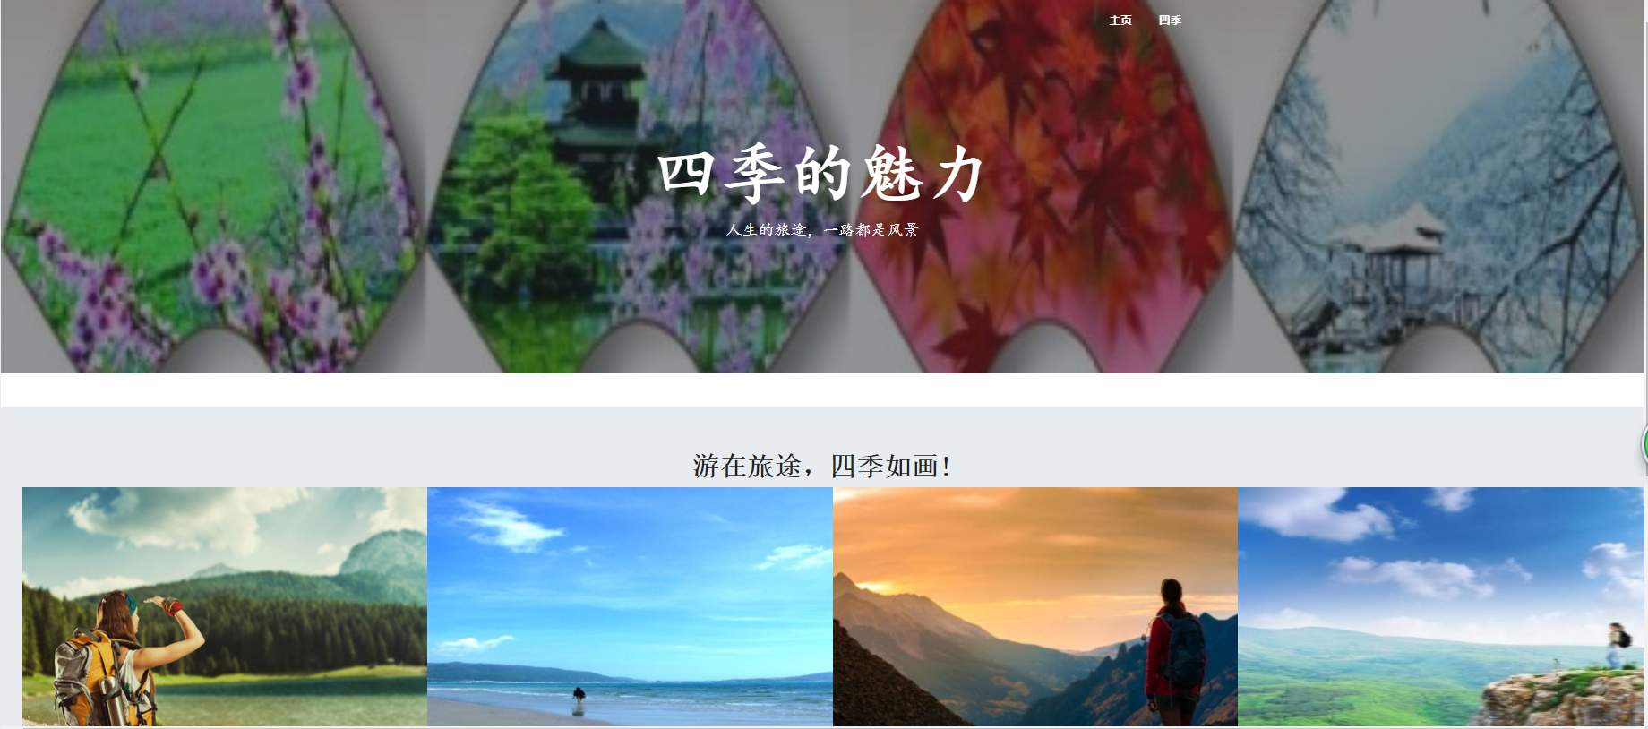

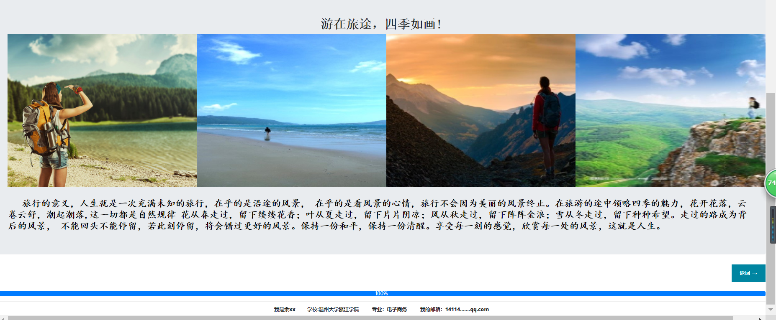

1. **shun.html**

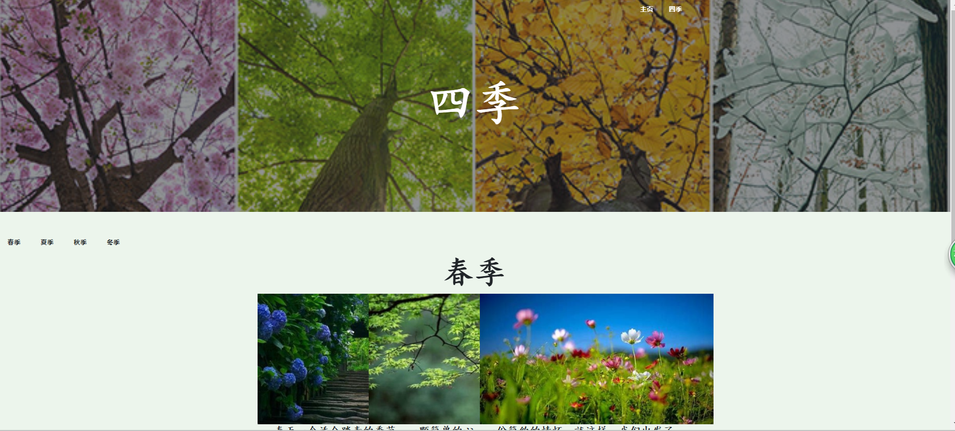

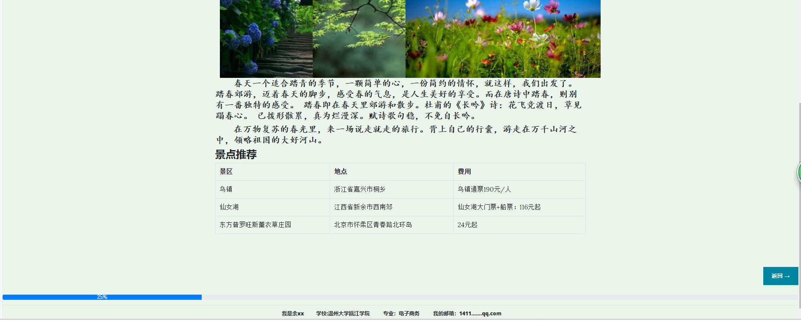

1. **xia.html**

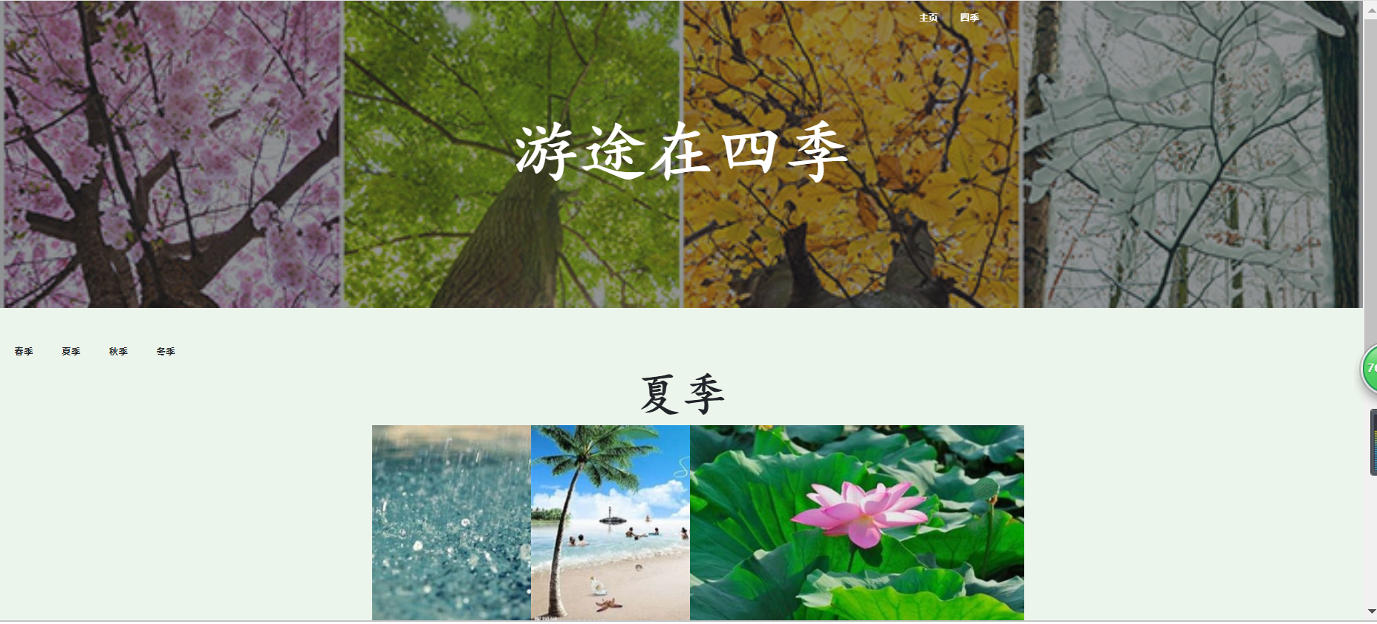

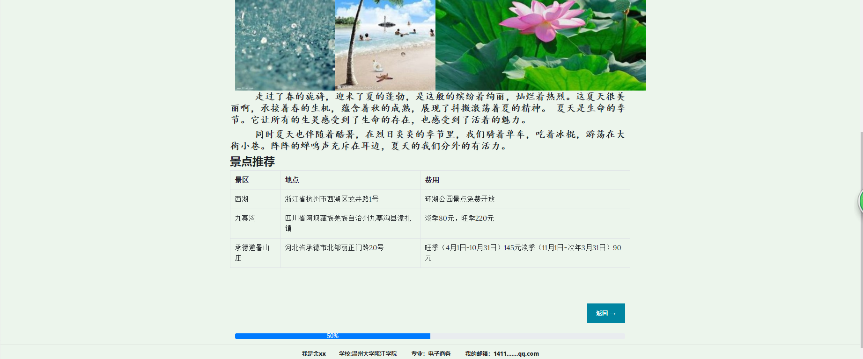

1. **qiu.html**

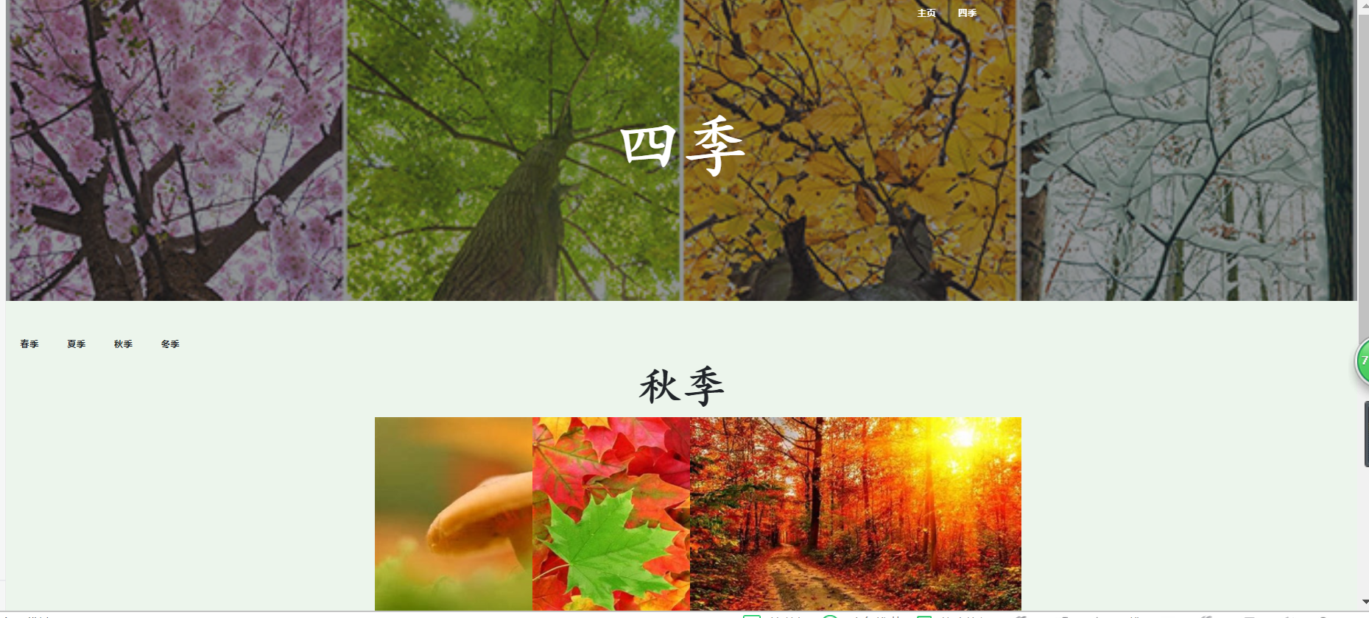

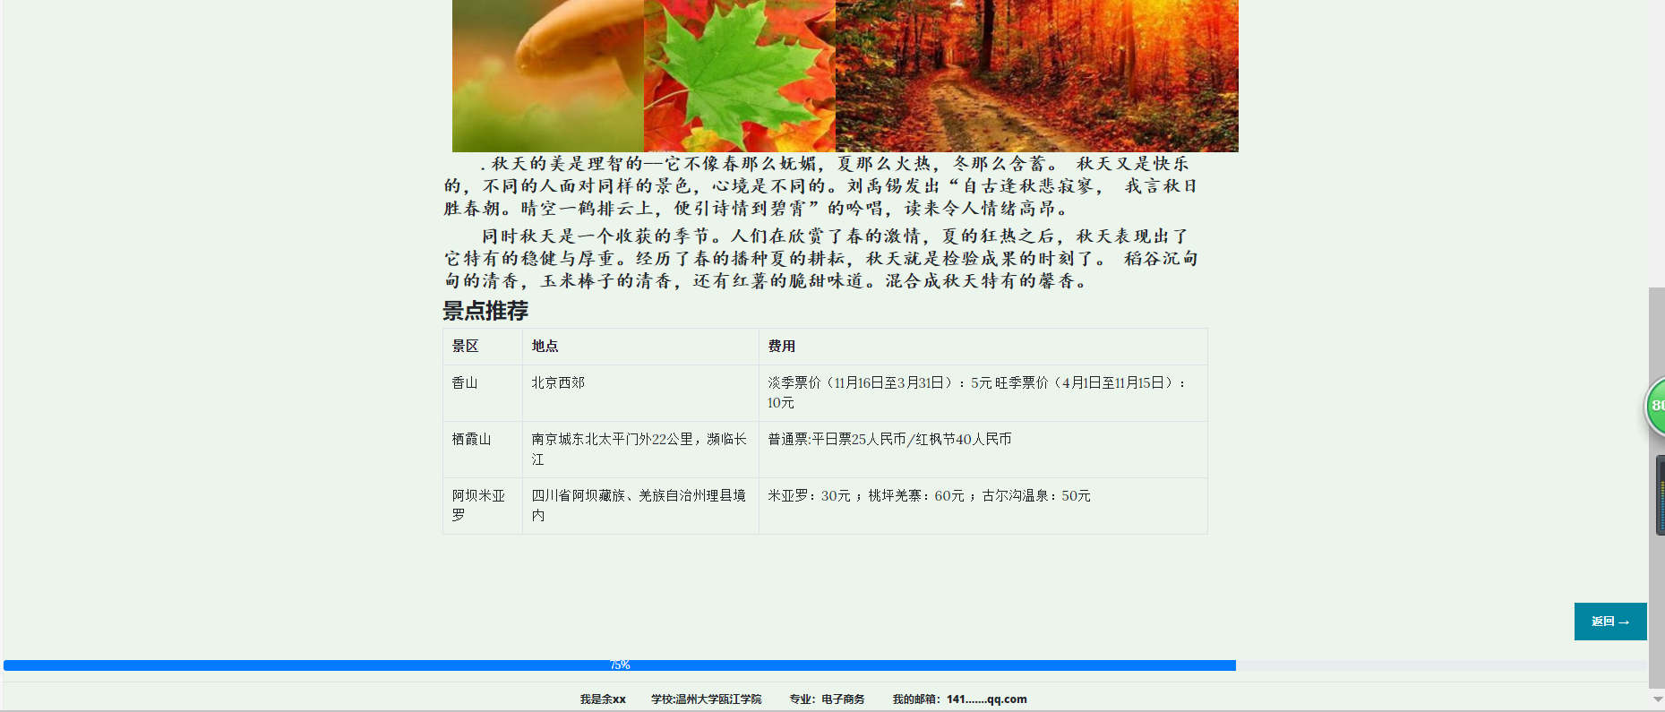

1. **dong.html**

